InstaMeme! 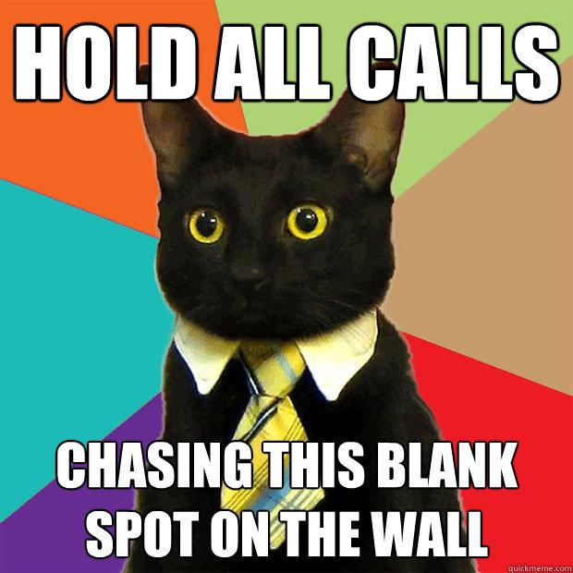

Developed By:

Niklas Bauer

Curtis Schumacher

**Description**

InstaMeme is a simple, fun android app that allows you to make meme photographs of yourself and friends! Use the quick interface to bring up your camera, snap a pic, and lay some meme text on top!

Don’t want to take a picture? No problem! We provide some “stock” Meme Photographs for you to get started! **More coming soon!**

Want to use a picture you’ve already taken through InstaMeme or any other camera app? Go ahead! Just select one from your phone’s gallery. You can also select from Google Drive!

You can save your pictures, before and after you’ve added text, so you can keep coming up with more Memes, or share the ones you’ve made.

Correct, you can also share your pictures on Twitter. Select “post” and your picture will be posted on Twitter along with any text you choose! Don’t go past the word limi-

We’ll be adding more as soon as we can, Facebook, Reddit, email, and Pinterest to be added soon.

**How-to-Instameme:**

**1) Select the Scumbag Kitty!**

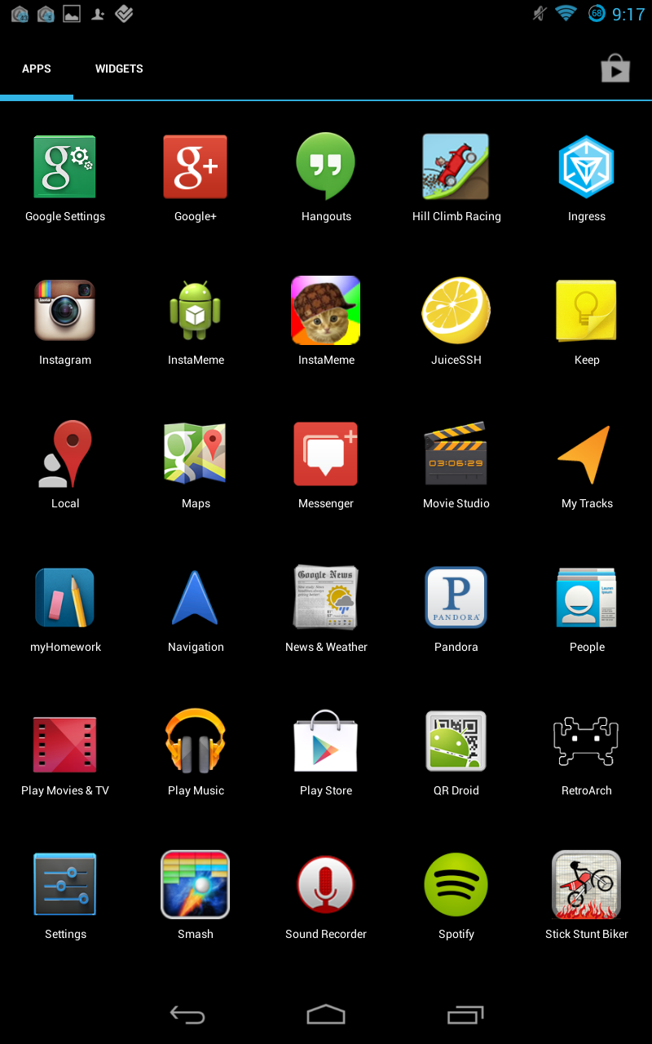

**2) Select “Take a Photo!” If you want to, you know, take a photo, or go to step 4**

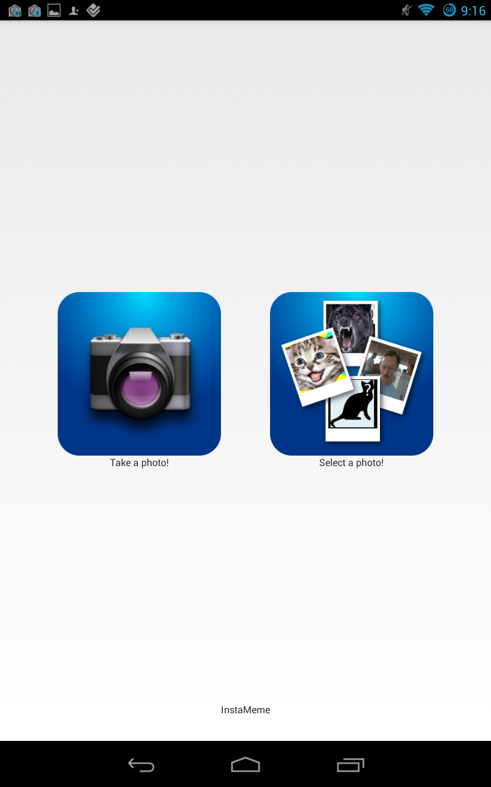

**3)Hit the button that we’re pointing at to take a photo!**

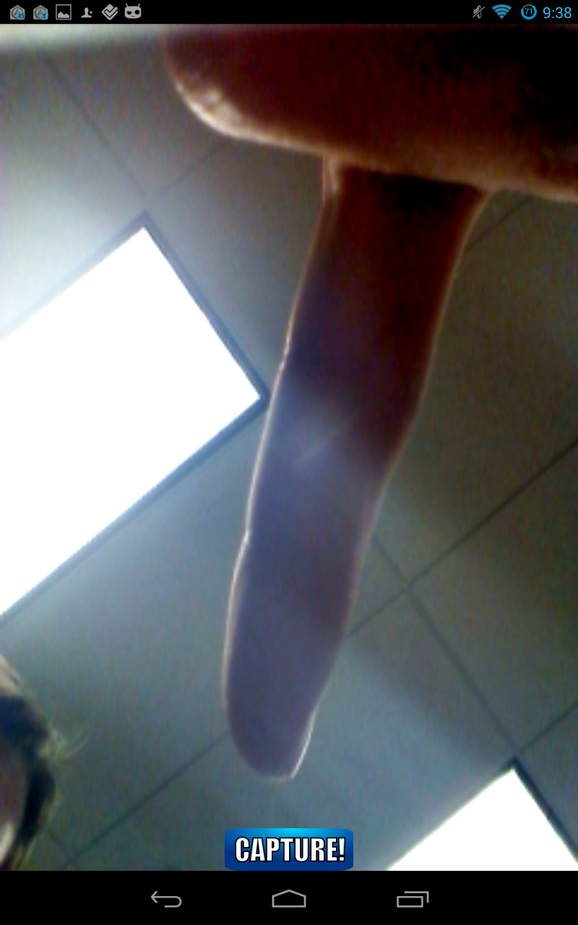

**4)Didn’t want to take a photo? We have you covered!Pick “Select a Photo” in the main screen**

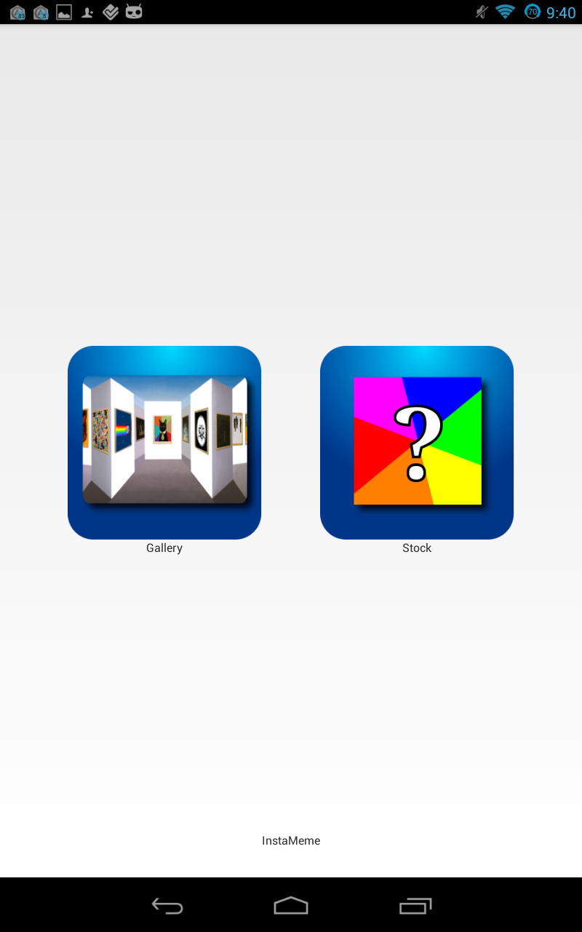

**5a) Select from your phones gallery or...**

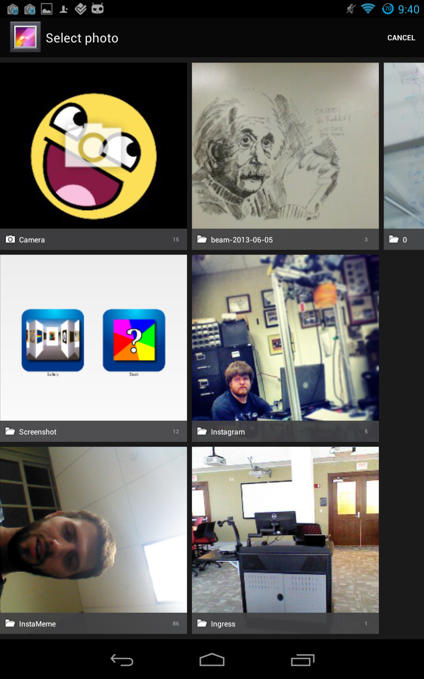

**5b)From our provided “stock” memes!**

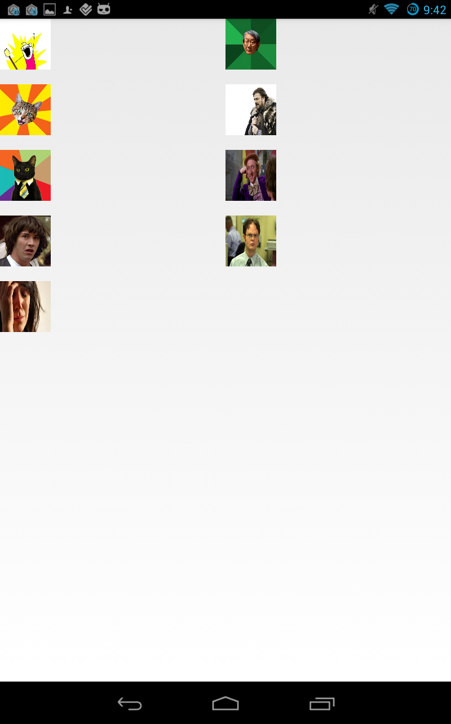

**6) Click on the gray bar you want to add text to, you don’t need to add text! (Don’t worry, the gray bar won’t be part of the photo)**

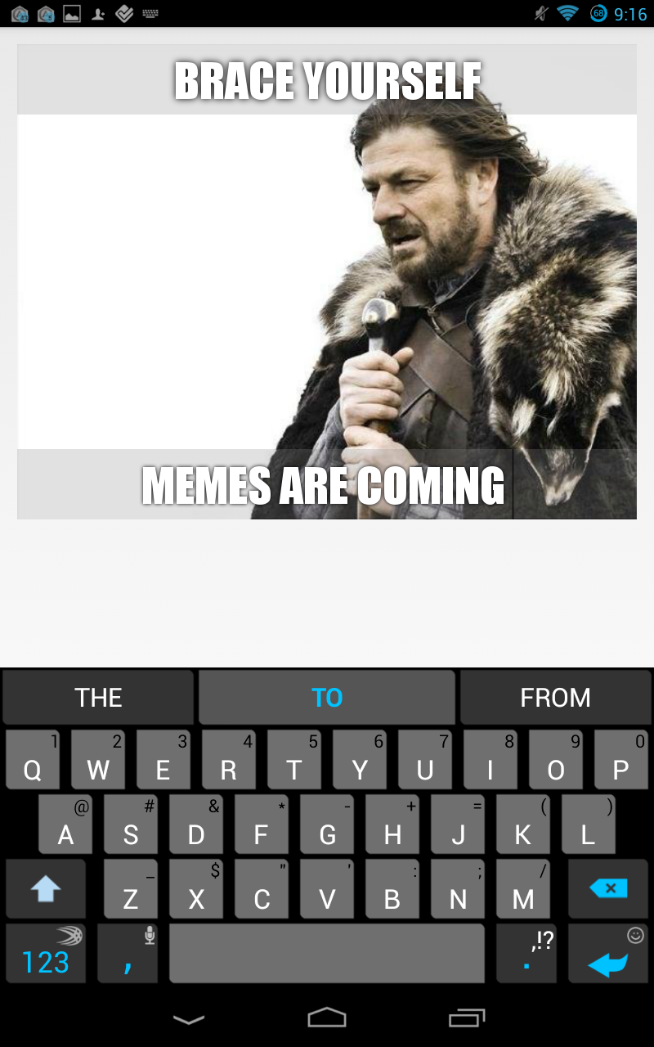

**7) Minimize your keyboad. Look, there are buttons!**

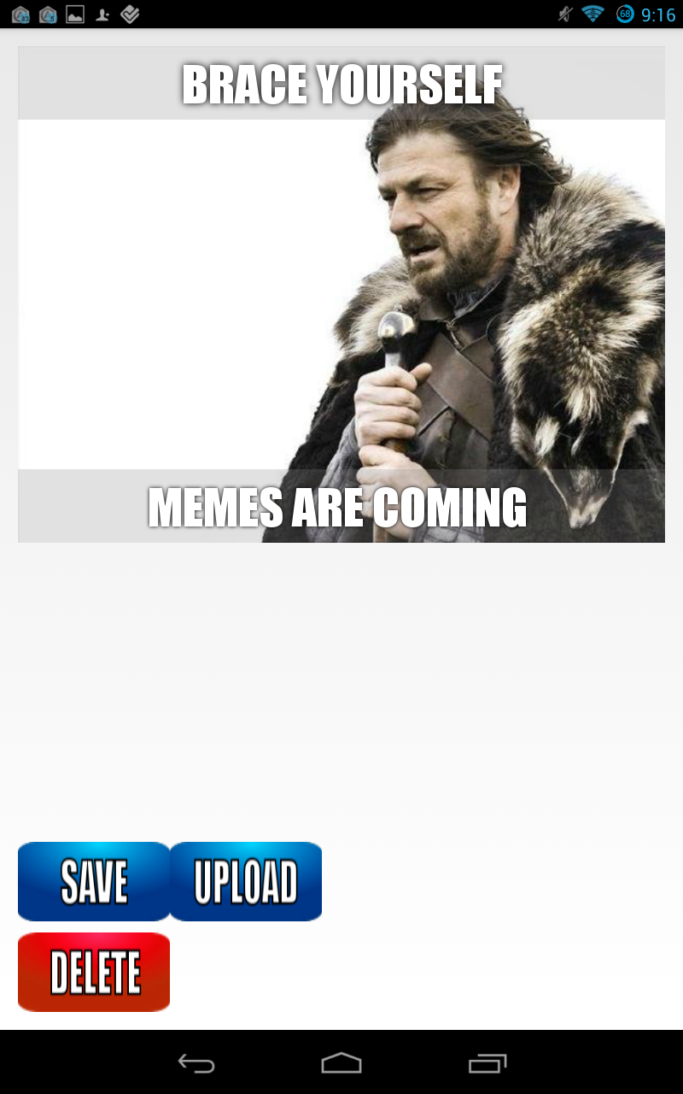

Save: Puts the photo in a folder in your Gallery

Upload: Saves the photo if it hasn’t been saved, and gets it ready to post online

Delete: Wipes the text off the image

**8)Enter text if you want to tweet words with the image, and hit the Twitter icon to post it!**

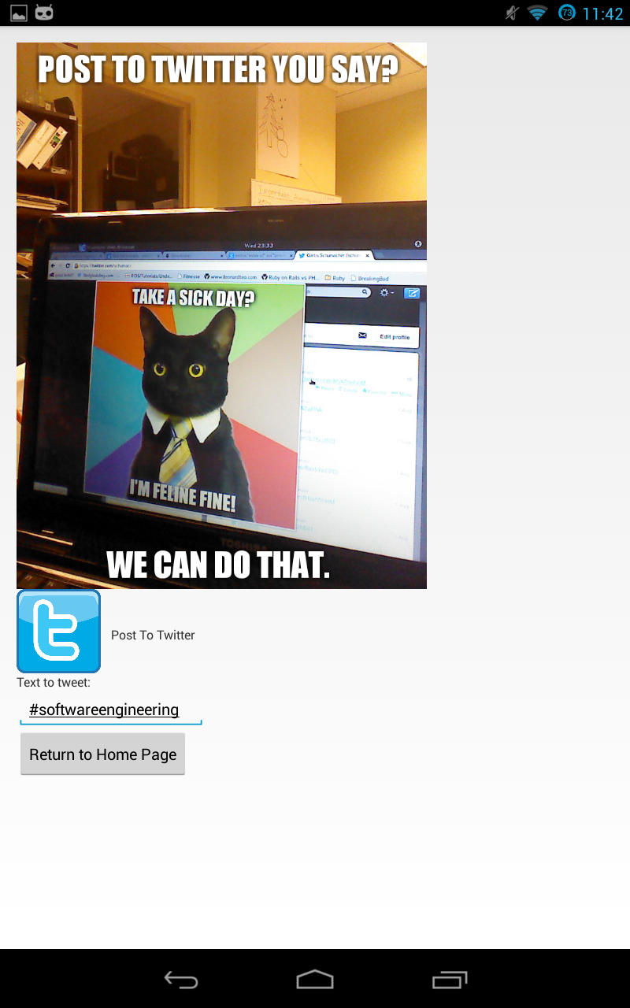

**9)Enter your information if you’re not logged in**

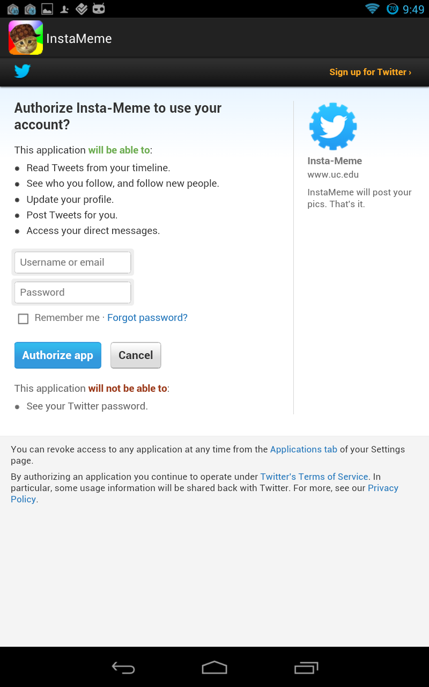

**10)Instameme isn’t evil, we don’t keep any of this information or spam you or your friends. It’s your job to spam them with memes.**

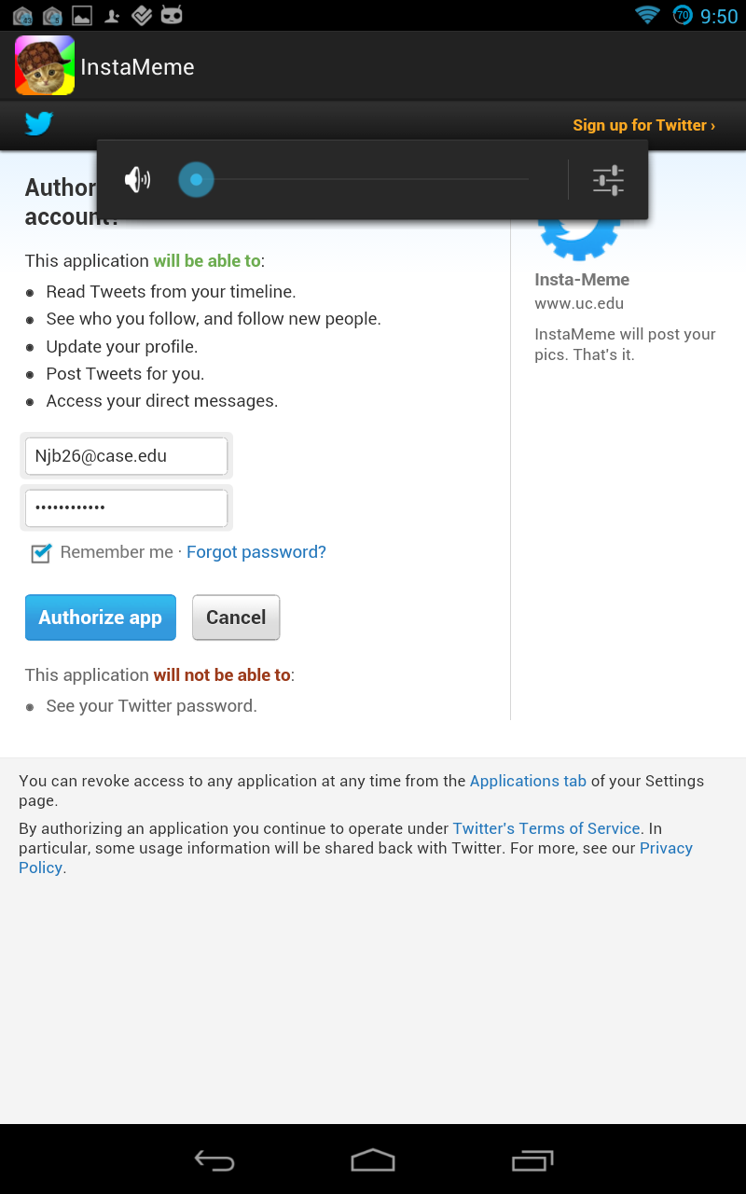

**11) And you’re done!**

**Now download this and start turning your friends into memes!**